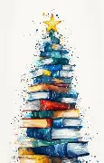 | Recommended reading  - These Christmas book recommendations are all available in our Reading Realm.

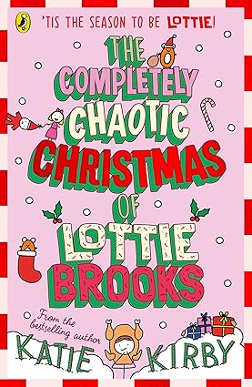
Year 7-8
The completely chaotic Christmas of Lottie Brooks, Katie Kirby
Christmas is here—and everything is going wrong! From family drama to festive disasters, Lottie’s diary is full of laugh-out-loud moments and relatable chaos. If you love funny, feel-good stories with plenty of festive fun, this is the perfect festive read.

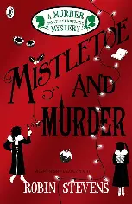
Year 9-10
Mistletoe and Murder, Robin Stevens
It’s Christmas at Cambridge University, but Daisy and Hazel’s holiday takes a dark turn when a murder occurs! Can the Detective Society solve the case before the killer strikes again? Full of festive fun, clever clues, and shocking twists, this mystery is perfect for fans of thrilling detective stories.

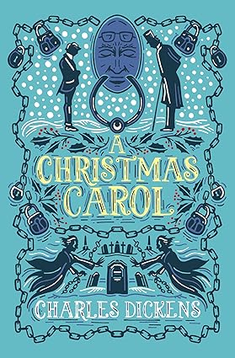
Year 11-13
A Christmas Carol, Charles Dickens
Step into Victorian London and meet Ebenezer Scrooge—a man who hates Christmas! When three ghosts visit him on Christmas Eve, his life changes forever. This short, powerful story is full of mystery, drama, and an important message about kindness and caring for others. Perfect for getting into the festive spirit and thinking about what really matters.

